Title: Atomic Layer Deposition and architected carbon: A synergistic mix for bottom-up Materials Synthesis.
By: Jan Torgersen
Abstract:
Atomic Layer Deposition (ALD) is a widely used technique for applications in energy conversion and storage. However, other fields of engineering are increasingly adapting this technology for a wide range of purposes. In the first part of this talk, unusual applications of ALD are introduced. This includes the fabrication of novel M/NEMS devices for the creation of in situ TEM gas chambers, the tailoring of biological interfaces for enhancing osteogenesis of stem cells and the tuning of the degradation behavior of Mg alloys.
Despite its ability to coat 3D structures with conformal layers, ALD requires a substrate. To unlock its full abilities, it can be combined with a technology that allows the creation of precise 3D architectures with computer defined shapes. In the second part, this talk introduces a novel method for fabricating computer defined carbon architectures from patterned photopolymers, a field termed architected carbon. This talk will give an overview of the recent advances in precursor development as well as temperature programs to achieve architected carbon in the cm scale while retaining its nanoscale features. We show the fabrication of standard test specimens according to the ISO 527-1 standard and present initial macroscopic mechanical properties and their relation to the size and microstructure of the carbon architecture. A wide range of applications are envisioned including novel electrode designs, carbon microelectromechanical systems, highly load bearing and lightweight structures, AFM tips and X-ray optical lenses.
The presented technologies may be useful for your research to create prototypes for a variety of purposes, which we can discuss during (and after) the seminar.

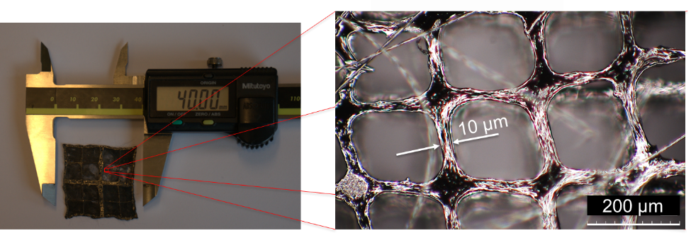
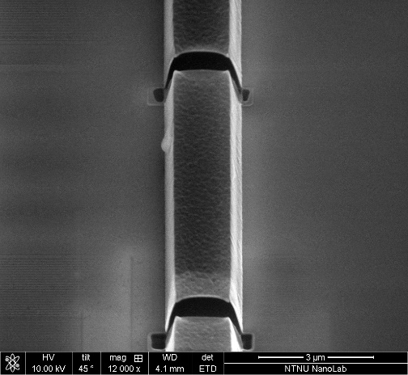
(a)
(c)
(b)
Figure 1: (a) 50 nm free standing Al2O3 membrane shell structures synthesized by Atomic Layer Deposition, (b) and (c) Multiscale electrode for Polymer Electrolyte Membrane Fuel Cells

